|  |  |  |  |  |  |
| --- | --- | --- | --- | --- | --- |
| Date | 1-Dec-22 | | | Tester Name | Andrew McLaughlin |
| Environment | Penfax - Test | | | Login used |  |
| Operating System | Select OS | Version: | Update: | | |
| Software Used | Select Software | Version: | Update: | | |
| Select Software | Version: | Update: | | |
| Release version | 22.4.1 | | | | |
| Title | New Beneficiary(ies) Retro calculated correctly | | | | |
| Test Type | Regression | | | | |
| Test Scenario | New Beneficiary(ies) Retro calculated correctly | | | | |
|  |  | | | | |
| Expected Results |  | | | | |
| Pass/Fail | Pass | | | JIRA# | N/A |

Describe your steps with screenshots:

Add a date of death to a member at least 1 month before the current payroll month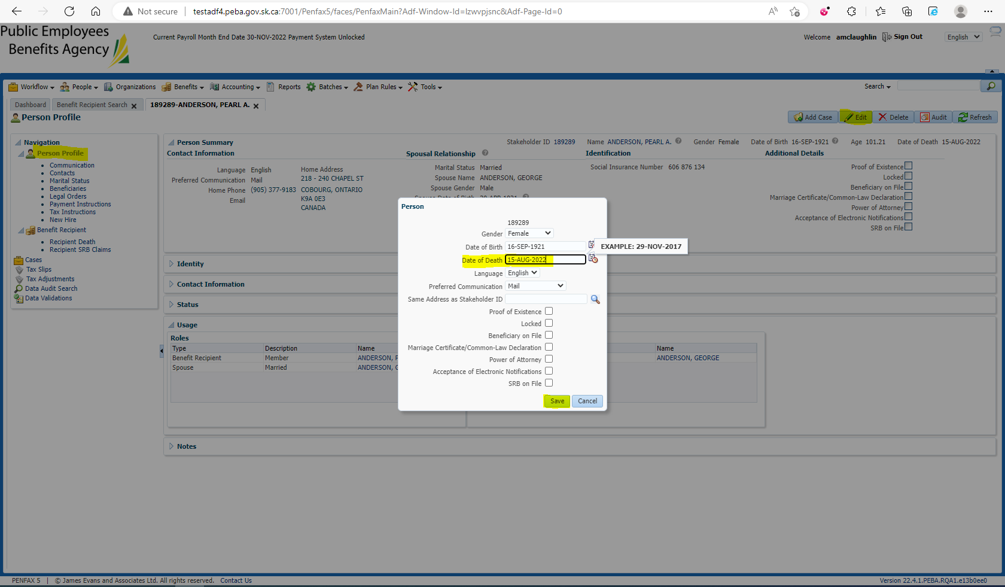

Open the member’s Benefit Event ID. Add the spouse to the Benefit Recipient with Start Date as the 1st of the month after the member passes away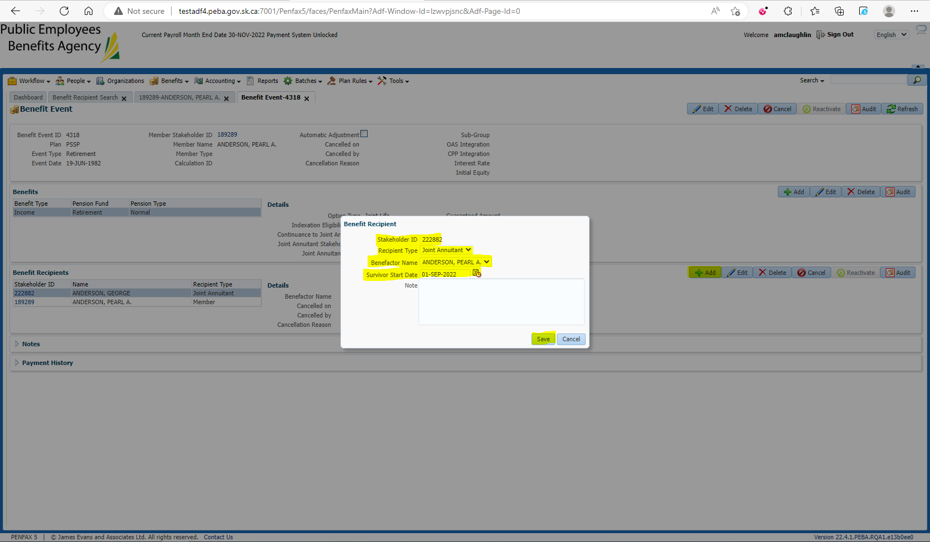

Run the member’s Death Calculation, Process x2, Process Recipient x2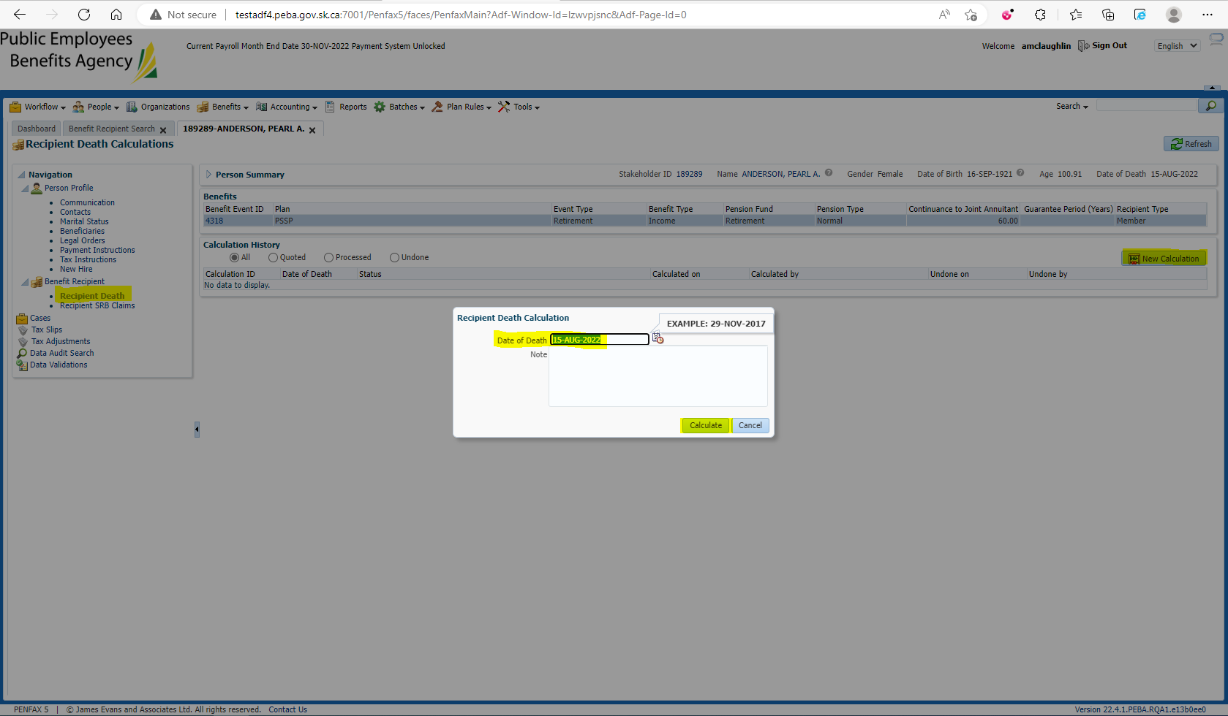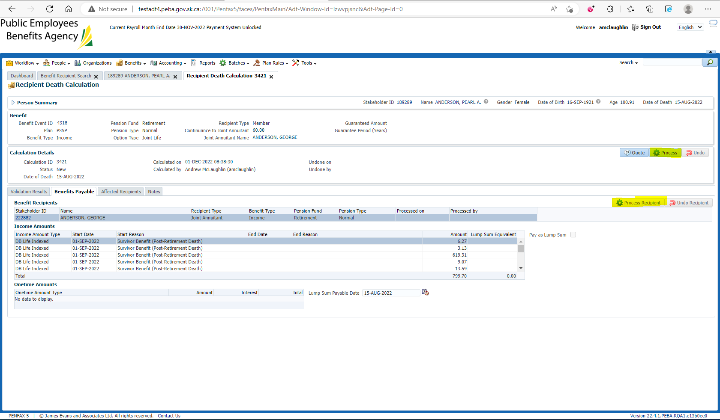

Process the Retros in the Spouse’s Retroactive Adjustments tab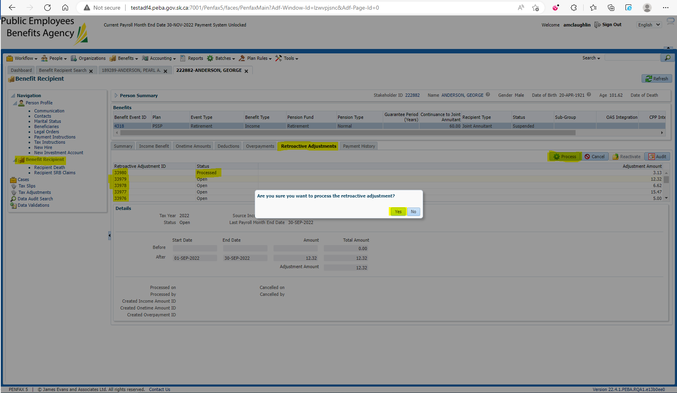

Under the Outstanding Onetime Amounts, the Amount should be equal to the missed payment: $799.70 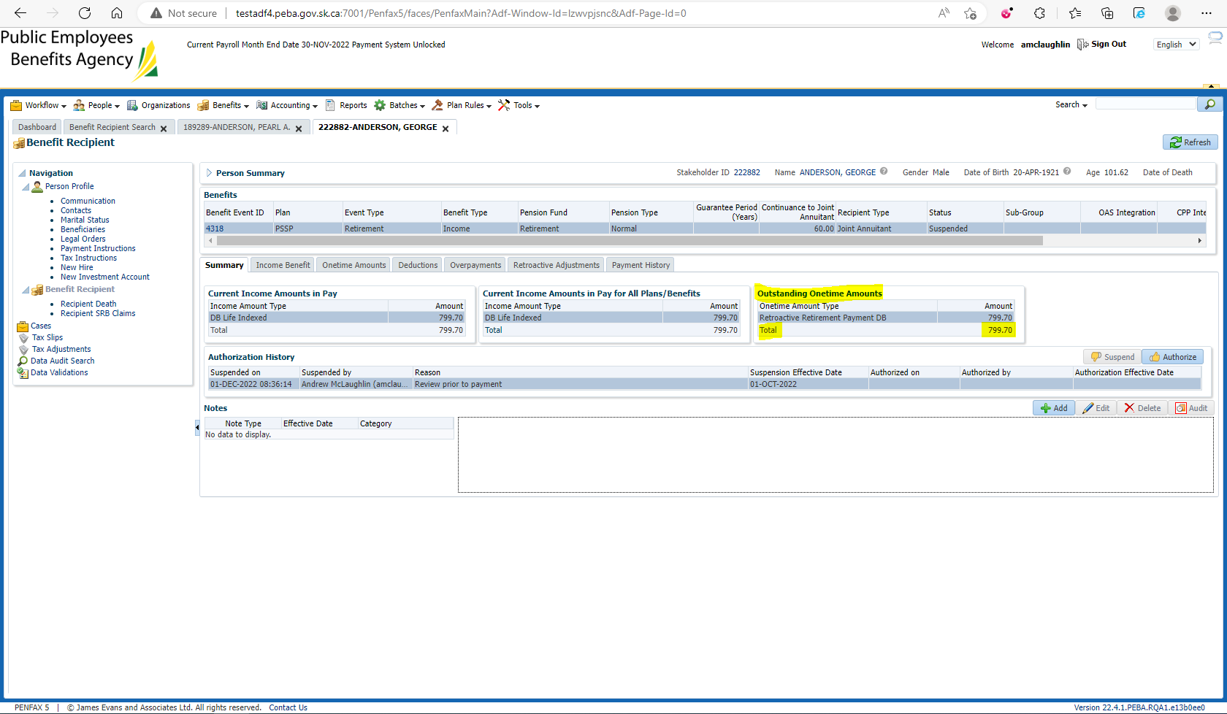

Continuance is calculating correctly:  
Member Payment = $1,332.82 * 0.60 = $799.69

Within a penny is acceptable due to unseen rounding in the other calcs.